Predict Report

Astro 321, M5

Lt Col Seo

C2C Shankar Kulumani

27 November 2007

ABSTRACT

Satellite prediction software is created with emphasis on the ability to view low earth satellites from any location. The ability to locate low earth objects remains extremely valuable to US national interests. A computer program computes the topocentric range, azimuth, and elevation to any satellite illuminated by the sun, elevation above 10 degrees and within 1500 km. Results show that the computer program can accurately calculate viewing data for low earth satellites. With user inputted TLE data, the program can calculate viewing data from any location on the earth.

Key Words: Space Surveillance, Predict, Low Earth Satellite

TABLE OF CONTENTS

Introduction ……………………………………………………………………………………….4

Assumptions……………………………………………………………………………………….4

Math Technique…………………………………………………………………………………...5

Analysis and Discussion…………………………………………………………………………..8

Sources of Error and Recommendations………………...………...……………………………...8

Appendix A – Program Usage…………………………………………………………………….9

Appendix B – Results……………………………………………………………………………11

Appendix C – STK Verification…………………………………………………………………15

I. INTRODUCTION

The ability to predict and view low earth satellites is an important skill in an ever-changing world. Many government organizations, such as NORAD, can view and track low Earth satellites with amazing accuracy. However, these operations are expensive and time consuming. In order to view a low Earth satellite we must first calculate its orbit. Orbital data can come from NORAD or other sources. In addition, the program COMFIX can convert radar observations into orbital elements. However, these orbital elements are only valid for that instant in time. In order to view the satellite, our system must propagate the orbital elements forward from the epoch to our viewing window. Using the current orbital elements our system can then calculate the topcentric range, azimuth, and elevation from the observation site to the satellite.

II. ASSUMPTIONS

The Predict program makes use of several assumptions to simplify the process of predicting satellite passes. When updating the orbital elements to the viewing window we considered only J­2 and drag as our perturbing force. By limiting the perturbing forces to only J2 and drag, we can determine analytical equations that model the changes in our orbit. In addition, the J2 and drag forces are much larger than other perturbing forces such as third body effects. In low earth orbit, the effect of J2 and drag far outweigh the effect of other perturbing forces. During the short time period of updating the orbital elements, other perturbing forces play a minimal role. Another assumption that was made involved solving Keplers problem. Only a second order Taylor series is used to calculate mean anomaly and solve Keplers problem. By limiting the solution of Keplers problem to a second order Taylor series, we do not need to calculate any new properties of our low earth object. The TLEs provided by NORAD supply both mean motion and the mean motion rate. Limiting the solution to a second order Taylor series allows us to use the provided data from the TLEs. In order to determine if the object is visible from the observation site we made several assumptions. First, we assumed that any visible object must lie within 1500 km of the observation site. There is a limit to the angular resolution of the naked eye. This limit may not accurately capture the angular limit however it is a good approximation. We also assumed that for the object to be visible the observation site must lie in darkness and the sun must illuminate the object. In order to calculate when the observation site and satellite are in the sunlight we assumed that the shadow of the earth formed a perfect cylinder. Figure 1 shows how we ignored the effect of the atmosphere and its effect upon the shadow of the Earth.

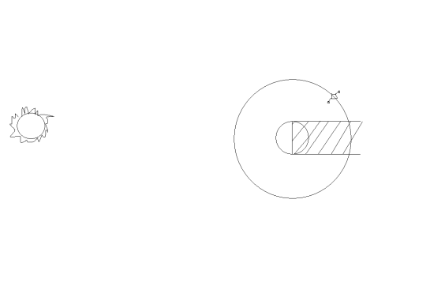

FIGURE 1. Shadow of the Earth

III. MATH TECHNIQUE

To determine the range, azimuth, and elevation from our observation site to the object we need to propagate the orbital elements forward from the epoch date to our viewing time. We use a first order Taylor series approximation to calculate the value of e, i, Ω, and ω. We use a second order Taylor approximation to calculate the mean anomaly. As stated earlier we have limited the perturbing forces to only J2 and drag. As a result, only Ω, e, and ω are affected by these perturbations. The following equations were used to calculate the effect of drag and J2 upon or low earth object.

 (1)

 (2)

 (3)

 (4)

Applying a first order Taylor series with the previous rates, we can then calculate the orbital elements at our viewing time. Using previously determined methods, we can convert the orbital elements into a position vector. The observation site vector is calculated in the same manner as COMFIX. After calculating the position vector of the object, we can easily calculate the range, azimuth, and elevation. Equation 5 illustrates how the range vector is calculated.

$\overset{⃑}{ρ}=\overset{⃑}{R_{sat}}-\overset{⃑}{R_{site}}$ (5)

Using the range vector the range, azimuth, and elevation are easily found using simple geometry. The following equations show the process of finding range, azimuth and elevation.

$ρ=\left|\overset{⃑}{ρ}\right|$ (6)

$El=\sin^{-1}{\frac{ρ}{ρ_{z}}}$ (7)

$Az=\tan^{-1}{\frac{ρ_{e}}{ρ_{z}}}$ (8)

Next, we must ensure that the object is visible from the observation site. For the object to be visible, the observation site must be in darkness while the object is in sunlight. In addition, the elevation must be greater than 10° and the range less than 1500 km. In order to determine if the observation site is in darkness we can apply Figure 2. The angle between the sun vector and the site vector must be greater than 90° to pass this step.

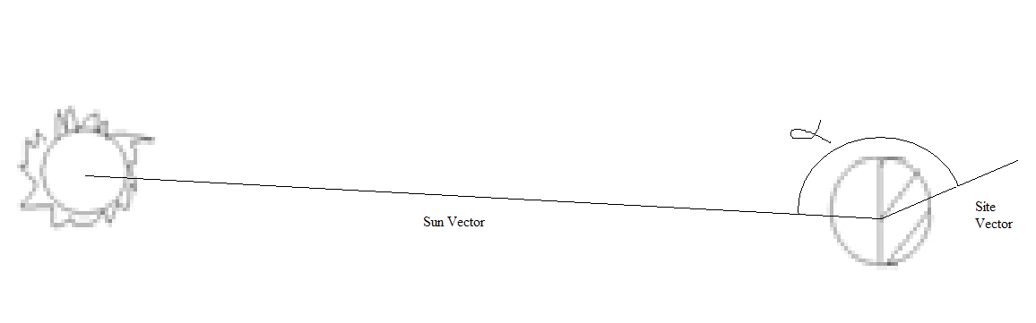

FIGURE 2. Site Darkness Test

In order to test if the object is illuminated it must not be within the span of the Earth’s shadow. Figure 3 shows how we can apply simply geometry to test this step. The vertical component of the satellites position must be greater than the radius of the earth.

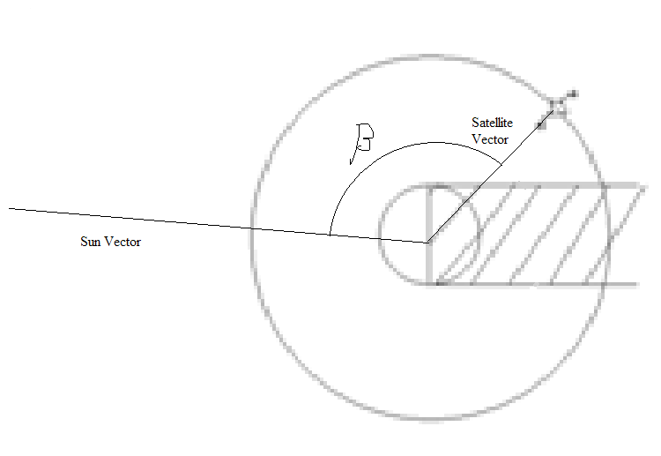

FIGURE 3. Satellite Illumination

IV. ANALYSIS AND DISCUSSION

Matlab proved the ideal choice in creating this program. Comparing output with that of the provided test case proved that the program worked properly. The program outputs the range, azimuth, and elevation of visible objects in two-minute intervals. The object that I viewed was the Thor Agena D Rocket Body. It was challenging to transfer the data provided into actually viewing the object. The times provided are not exact and therefore requires estimation to achieve the best results. However, this program did provide accurate enough data to view a low earth object.

V. SOURCES OF ERROR AND RECOMMENDATIONS

By limiting the perturbing forces to only J2 and drag, we ignored several large factors that can influence our prediction. Applying more perturbing forces can help to minimize the difference in the data provided and actual observations. However always applying current TLEs can also solve this problem. We can improve our program by creating a more robust visibility test. Applying atmospheric effects as well as topographical data can greatly improve the visibility test. This will create a better chance of viewing the object and eliminate much of the chance involved.

APPENDIX A – PROGRAM USAGE

Program Name – Predict

Program Function - This program takes TLE data and computes the topocentric range, azimuth, and elevation at two-minute intervals given user inputted observation site and observation window.

Computer Used – Windows XP PC

Language Used – Matlab 7.4.287 (R2007a)

Program Usage-

1. Copy and paste latest TLE data into TLE.txt
   1. This is the input file used by the program – can be changed within main Predict program
2. Run Predict.m
3. Predict will prompt for the observation site location
   1. Enter the observation site latitude in degree decimal format
   2. Enter observation site longitude in degree decimal format
   3. Enter observation site altitude in kilometers above sea level
4. Predict will prompt for observation year
   1. The year must be greater than the year 2000
5. Predict will prompt for the day of the year to start and end the observation
   1. The day of the year is the calendar day between 1 and 365 or 366 if a leap year
6. Predict will output the data for all satellites from the input file to ViewSat.txt
   1. The time provided is in Universal time – must be converted to local time
   2. The range provided is in kilometers from the observation site to object
   3. Azimuth is in degrees from true north
   4. Elevation is in degrees from the local horizon

APPENDIX B – RESULTS

*********************************************************************

Echo Check Input Data for: THOR AGENA D R/B

*********************************************************************

Epoch Year = 2007

Epoch Day = 329.55630868

N Dot/2 = 0.00000038 rev/day^2

Inclination = 99.10730000 deg

RAAN = 312.01550000 deg

Eccentricity = 0.00335310

Arg of Perigee = 244.53040000 deg

Mean Anomaly = 115.24160000 deg

Mean Motion = 14.31200464 rev/day

Echo Check Working Units

Epoch Time (month/day, hr:min:sec) = 11/25, 13:21: 5.07

Epoch Julian Day (days) = 2454430.05630868

N = 0.00104079835 rad/s Ndot2 = +3.19842359065e-016 rad/s^2

Ecc = 0.00335310000 Ecc dot = -4.08608968195e-013 1/s

Inc = 1.72974869776 rad Mean Anom = +2.01134535527e+000 rad

RAAN = 5.44569779226 rad RAAN dot = +2.11824964344e-007 rad/s

Argp = 4.26786060122 rad Argp dot = -5.85308781728e-007 rad/s

MONTH/DAY HR:MIN (UT) RHO(KM) AZ(DEG) EL(DEG) VIS?

---------------------------------------------------------------

11/25 12:18 1137.493 345.982 41.529 Yes

11/25 12:20 919.152 265.820 58.456 Yes

11/25 12:22 1361.427 220.206 30.846 Yes

11/25 23:36 1130.493 267.842 42.770 Yes

11/25 23:38 1469.898 311.666 28.552 Yes

11/26 11:48 1043.861 35.782 47.298 Yes

11/26 11:50 871.526 145.139 64.531 Yes

11/26 11:52 1370.312 179.901 30.372 Yes

*********************************************************************

Echo Check Input Data for: SL-8 R/B

*********************************************************************

Epoch Year = 2007

Epoch Day = 329.70283282

N Dot/2 = 0.00000014 rev/day^2

Inclination = 74.01020000 deg

RAAN = 178.38230000 deg

Eccentricity = 0.00675680

Arg of Perigee = 350.98480000 deg

Mean Anomaly = 9.00950000 deg

Mean Motion = 14.42402866 rev/day

Echo Check Working Units

Epoch Time (month/day, hr:min:sec) = 11/25, 16:52: 4.76

Epoch Julian Day (days) = 2454430.20283282

N = 0.00104894496 rad/s Ndot2 = +1.17836658603e-016 rad/s^2

Ecc = 0.00675680000 Ecc dot = -1.48847021800e-013 1/s

Inc = 1.29172167006 rad Mean Anom = +1.57245438958e-001 rad

RAAN = 3.11335846228 rad RAAN dot = -3.75474112347e-007 rad/s

Argp = 6.12584038445 rad Argp dot = -4.22948683905e-007 rad/s

MONTH/DAY HR:MIN (UT) RHO(KM) AZ(DEG) EL(DEG) VIS?

---------------------------------------------------------------

11/25 0:50 1489.288 50.903 26.816 Yes

11/25 2:32 1239.021 267.023 35.918 Yes

11/25 2:34 1414.067 222.478 29.245 Yes

11/26 1:48 1223.930 328.057 36.581 Yes

11/26 1:50 840.144 269.027 70.646 Yes

11/26 1:52 1130.151 182.836 41.455 Yes

*********************************************************************

Echo Check Input Data for: SL-8 R/B

*********************************************************************

Epoch Year = 2007

Epoch Day = 329.21813418

N Dot/2 = 0.00000223 rev/day^2

Inclination = 74.03760000 deg

RAAN = 350.45410000 deg

Eccentricity = 0.00339710

Arg of Perigee = 149.52640000 deg

Mean Anomaly = 210.78940000 deg

Mean Motion = 14.84033228 rev/day

Echo Check Working Units

Epoch Time (month/day, hr:min:sec) = 11/25, 5:14: 6.79

Epoch Julian Day (days) = 2454429.71813418

N = 0.00107921942 rad/s Ndot2 = +1.87696963346e-015 rad/s^2

Ecc = 0.00339710000 Ecc dot = -2.31225177185e-012 1/s

Inc = 1.29219989027 rad Mean Anom = +3.67896905830e+000 rad

RAAN = 6.11657792211 rad RAAN dot = -4.00543230589e-007 rad/s

Argp = 2.60972799865 rad Argp dot = -4.52863319497e-007 rad/s

MONTH/DAY HR:MIN (UT) RHO(KM) AZ(DEG) EL(DEG) VIS?

---------------------------------------------------------------

11/25 12:18 1260.859 43.318 23.678 Yes

11/25 12:20 1285.884 88.103 22.785 Yes

11/25 13:56 1394.491 292.540 20.002 Yes

11/26 12:34 1021.662 11.968 32.503 Yes

11/26 12:36 771.967 88.350 48.792 Yes

11/26 12:38 1261.418 134.884 23.339 Yes

APPENDIX C – STK VERIFICATION

**Colorado_Springs-To-Thor_Agena**

**------------------------------**

**Time (UTCG) Azimuth (deg) Elevation (deg) Range (km)**

**------------------------ ------------- --------------- -----------**

**25 Nov 2007 12:16:49.661 357.394 26.953 1499.985905**

**25 Nov 2007 12:16:50.070 357.350 27.020 1497.683327**

**25 Nov 2007 12:17:50.070 347.763 38.738 1187.859423**

**25 Nov 2007 12:18:50.070 324.992 53.265 970.447863**

**25 Nov 2007 12:19:50.070 275.368 58.885 915.126202**

**25 Nov 2007 12:20:50.070 237.612 46.514 1048.199977**

**25 Nov 2007 12:21:50.070 222.522 32.671 1313.292636**

**25 Nov 2007 12:22:24.626 217.942 26.372 1499.986614**

**Min Elevation 25 Nov 2007 12:22:24.626 217.942 26.372 1499.986786**

**Max Elevation 25 Nov 2007 12:19:36.466 287.907 59.518 910.526977**

**Mean Elevation 38.802**

**Min Range 25 Nov 2007 12:19:37.192 287.228 59.516 910.512264**

**Max Range 25 Nov 2007 12:22:24.626 217.942 26.372 1499.986786**

**Mean Range 1241.572743**

**Time (UTCG) Azimuth (deg) Elevation (deg) Range (km)**

**------------------------ ------------- --------------- -----------**

**25 Nov 2007 23:36:13.709 275.251 41.590 1150.403301**

**25 Nov 2007 23:37:13.070 299.334 34.820 1292.287354**

**25 Nov 2007 23:38:04.478 312.608 27.542 1499.989051**

**Min Elevation 25 Nov 2007 23:38:04.478 312.608 27.542 1499.989051**

**Max Elevation 25 Nov 2007 23:36:13.709 275.251 41.590 1150.403301**

**Mean Elevation 34.651**

**Min Range 25 Nov 2007 23:36:13.709 275.251 41.590 1150.403301**

**Max Range 25 Nov 2007 23:38:04.478 312.608 27.542 1499.989051**

**Mean Range 1314.226569**

**Time (UTCG) Azimuth (deg) Elevation (deg) Range (km)**

**------------------------ ------------- --------------- -----------**

**26 Nov 2007 11:46:31.995 23.728 26.871 1499.985329**

**26 Nov 2007 11:47:31.070 29.414 39.217 1176.075483**

**26 Nov 2007 11:48:31.070 44.796 57.530 927.130246**

**26 Nov 2007 11:49:31.070 109.427 71.505 835.525508**

**26 Nov 2007 11:50:31.070 164.576 54.683 948.615046**

**26 Nov 2007 11:51:31.070 177.690 36.936 1210.176830**

**26 Nov 2007 11:52:23.291 182.376 26.249 1499.985410**

**Min Elevation 26 Nov 2007 11:52:23.291 182.376 26.249 1499.985410**

**Max Elevation 26 Nov 2007 11:49:27.116 102.960 71.616 835.205533**

**Mean Elevation 44.713**

**Min Range 26 Nov 2007 11:49:27.753 104.007 71.613 835.193247**

**Max Range 26 Nov 2007 11:52:23.291 182.376 26.249 1499.985410**

**Mean Range 1156.784836**

**Time (UTCG) Azimuth (deg) Elevation (deg) Range (km)**

**------------------------ ------------- --------------- -----------**

**27 Nov 2007 11:17:09.606 55.830 26.695 1499.990045**

**27 Nov 2007 11:18:09.070 73.633 33.033 1308.858705**

**27 Nov 2007 11:19:09.070 98.003 35.984 1235.095173**

**27 Nov 2007 11:20:09.070 122.515 33.042 1301.885275**

**27 Nov 2007 11:21:09.070 140.673 26.542 1490.463407**

**27 Nov 2007 11:21:11.471 141.254 26.260 1499.990069**

**Min Elevation 27 Nov 2007 11:21:11.471 141.254 26.260 1499.990069**

**Max Elevation 27 Nov 2007 11:19:09.115 98.023 35.984 1235.092417**

**Mean Elevation 30.259**

**Min Range 27 Nov 2007 11:19:10.621 98.675 35.982 1235.046917**

**Max Range 27 Nov 2007 11:21:11.471 141.254 26.260 1499.990069**

**Mean Range 1389.380446**

**Global Statistics**

**-----------------**

**Min Elevation 26 Nov 2007 11:52:23.291 182.376 26.249 1499.985410**

**Max Elevation 26 Nov 2007 11:49:27.116 102.960 71.616 835.205533**

**Mean Elevation 37.872**

**Min Range 26 Nov 2007 11:49:27.753 104.007 71.613 835.193247**

**Max Range 27 Nov 2007 11:21:11.471 141.254 26.260 1499.990069**

**Mean Range 1262.876591**

DOCUMENTATION

NONE